**Simple Job Creation for Jenkins Slave**

Lab goals: introduce with job architecture, creation a simple job.

Requirements: Basic bash and cmd skills, basic Linux and Windows knowledge.

Jenkins Job Introducing

Open home page of your Jenkins http:your-ip-address:8080 and click “Create new Jobs”.

Select “Build a free-style software project”

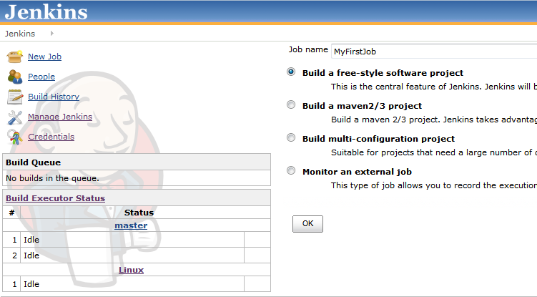

On the next screenshot shown the main points that are most often used.

1. This build is parameterized - you can specify any variables or parameters here.

2. Restrict where this project can be run - this option forces Jenkins to always build this project on a specific computer

3. Use custom workspace - this is the directory where the code is checked out and builds happen

4. Source Code management - no comments.

5. Build Triggers - you can specify schedule for job runs here.

6. Build - Main configuration section. All build steps such as script execution, trigerring another job, etc will be placed here.

7. Post-build Actions. - This is a section for such action as publish tests results, e-mail notification, archive the artifacts, etc.

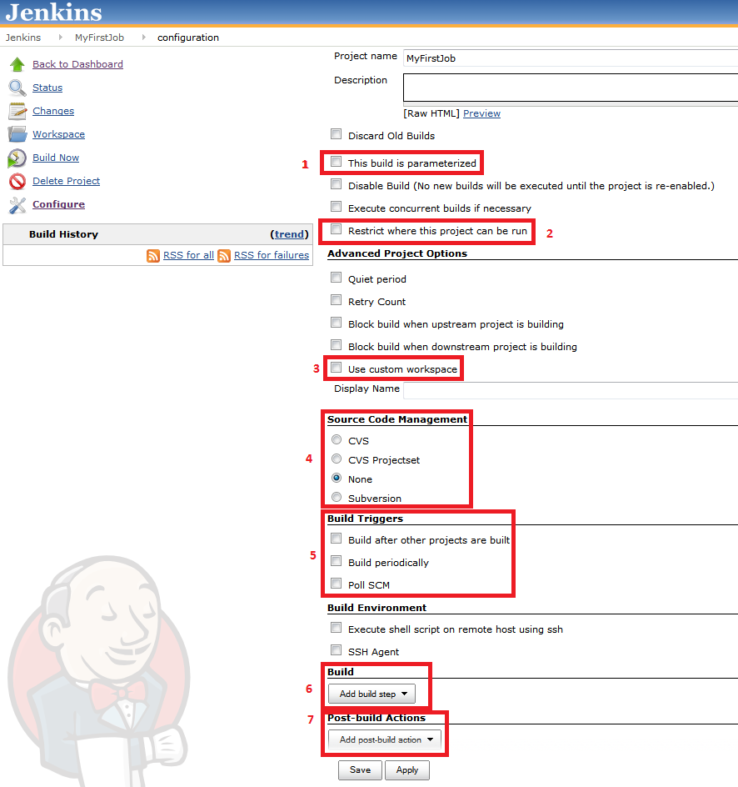

Lets configure the first job.

The job goal is to get a listing of remote directory.  
Value of remote directory must be parametrized.

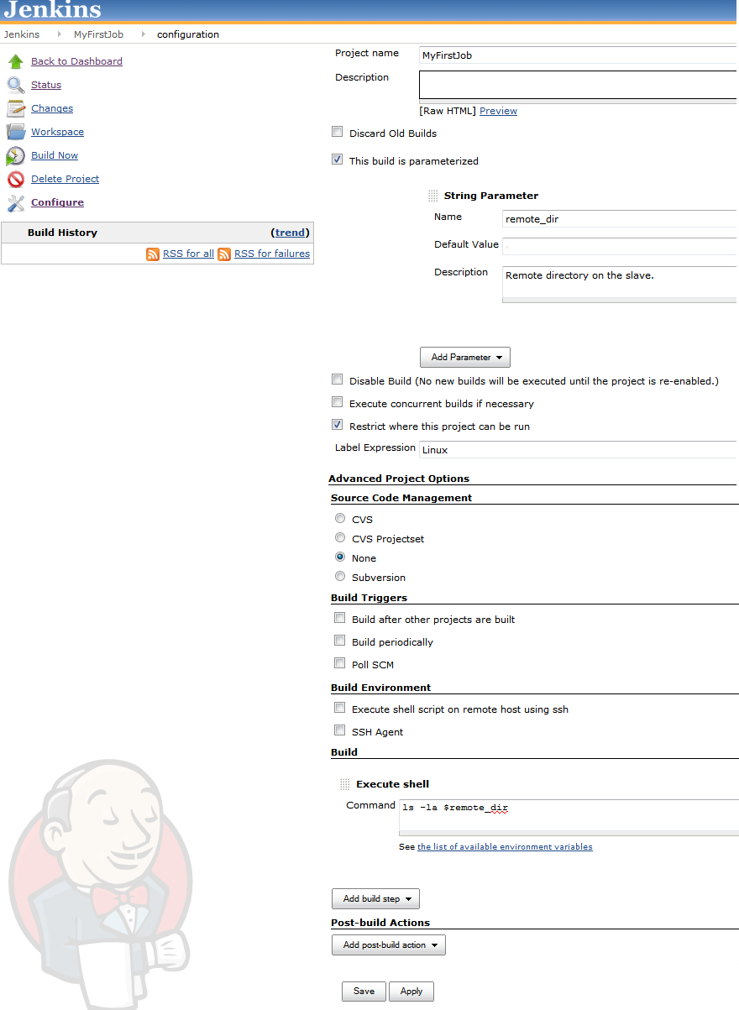

Save job and try to Build with parameter “remote_dir = /tmp”

You can see the result by clicking to ‘ball’ icon in Build History.

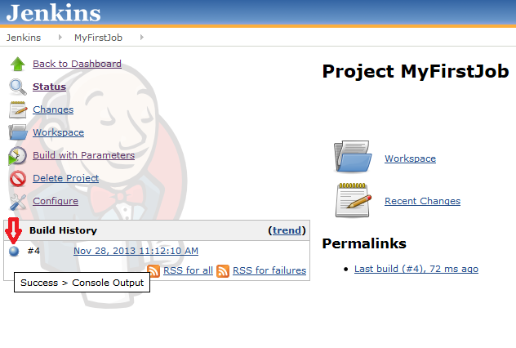

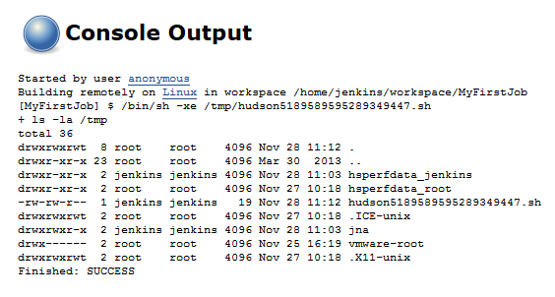

Tasks:

1. Create Job for getting time every 5 minutes on Linux slave.

Build history:

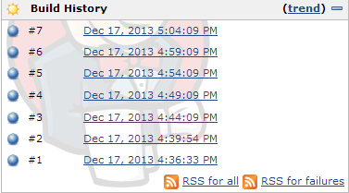

Console output (ls –la instead of time):

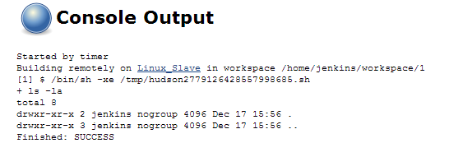

2. Create Job for getting time every 5 minutes on Windows slave.

3. Send screenshots with console outputs for both jobs.